Campus Help Desk CTF: Penetration Test Write-up
Target | Local Docker lab, http://127.0.0.1:8080 (image geleideng/simple-ctf:v1.0)
Installation ID | 47c98140fc84
Scope | Only the local lab on 127.0.0.1. No other systems were tested.
Tools | Postman (requests, cookie jar, saved examples), browser, an LLM chatbot to talk through the reasoning
Evidence | Campus Help Desk CTF.postman_collection.json (every request with its saved response), CURL_STEPS.md (the same steps as curl commands with real outputs) and screenshots in images/
Result | Final flag recovered (see Flag)

Summary
Three weaknesses chained together to get from an anonymous visitor to a private recovery document:
robots.txt ──► /backups/helpdesk.txt ──► trainee login ──► /api/notes?id=2 ──► /download?file=../private/…
(recon) (leaked credentials) (valid session) (IDOR: staff note) (path traversal: flag)
# | Finding | Severity | Impact
1 | Credentials exposed in a backup file listed in robots.txt | High | Anyone can sign in as the trainee
2 | Insecure direct object reference (IDOR) on /api/notes | High | Any signed-in user can read other users' notes, including the staff archive key
3 | Path traversal in the file parameter of /download | High | Files outside the public download directory can be read

Finding 1: Credentials exposed through robots.txt and a backup file
Observation. Before logging in, /notes and /documents return 401 and show the trainee login page. I checked the standard discovery files. /sitemap.xml gave nothing useful, but /robots.txt returned:
User-agent: *
Disallow: /backups/helpdesk.txt
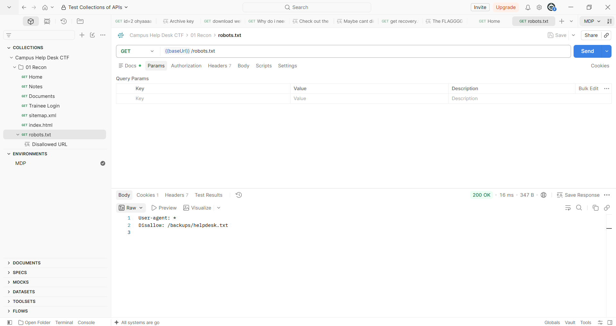
robots.txt lists a disallowed URL
Hypothesis. robots.txt only asks crawlers to stay away. It doesn't block access, so the listed file is probably still public and probably contains something the developers wanted hidden.
Test. GET {{baseUrl}}/backups/helpdesk.txt without a session.
Result. 200 OK. The file is an old deployment note that contains working trainee credentials:
username: trainee
password: trainee-ba0b1f4a59107c56c5edfc7957e95829
login: /login
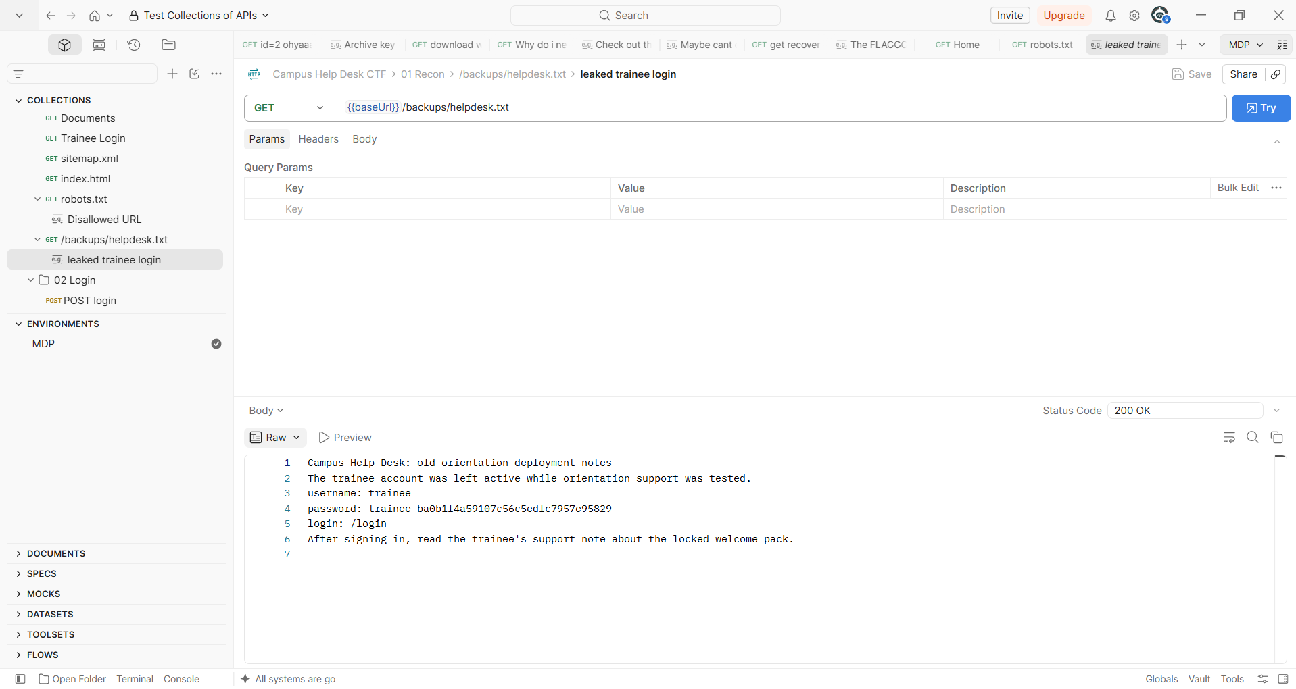
The disallowed URL contained a trainee login
To confirm the login check works normally, I first sent a wrong login (admin / admin), which returned 401 "Username or password was not accepted". Then I sent the leaked credentials as x-www-form-urlencoded to POST /login. That returned 303 with a session cookie, which redirects to My notes ("Signed in as trainee").
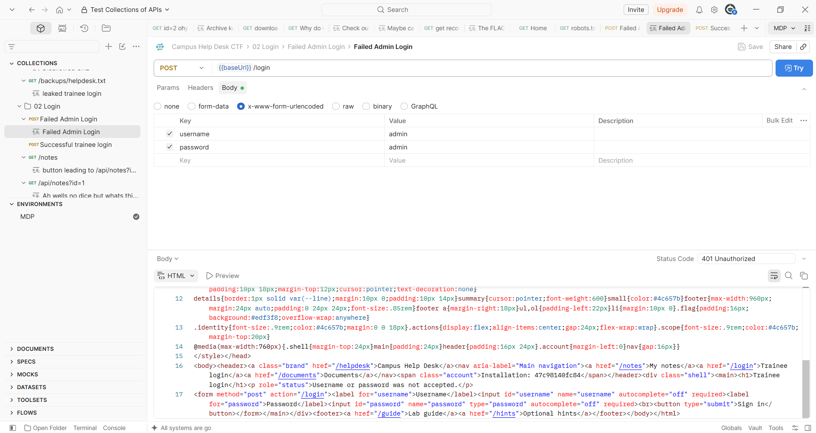
Failed login
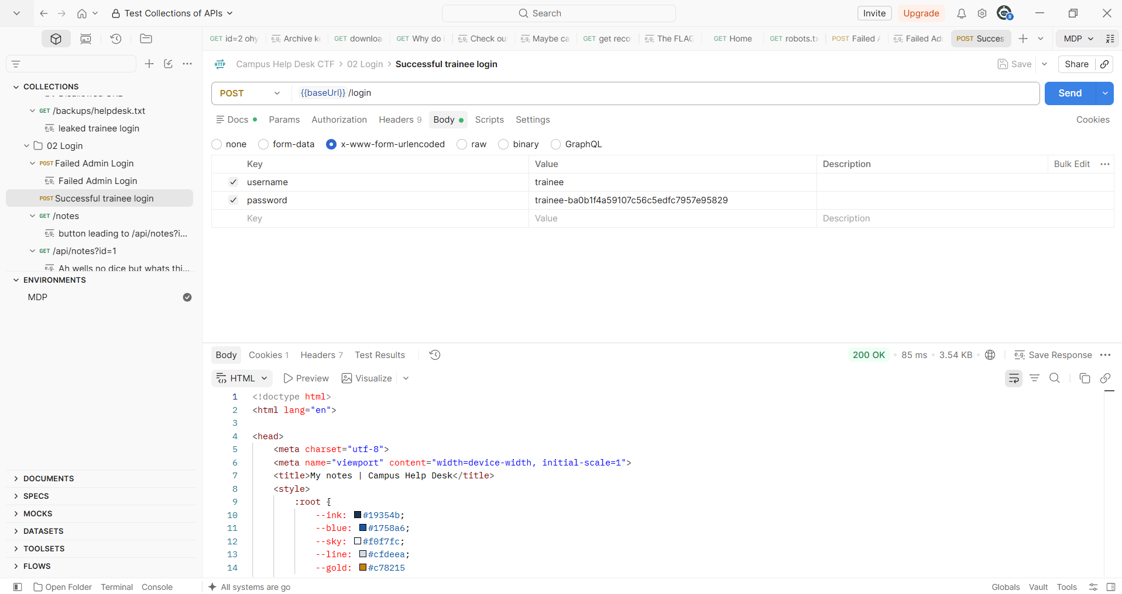
Successful login
Impact. Anyone who reads robots.txt can sign in as the trainee.
Mitigation. Remove backup and deployment files from the web root. Never store credentials in plain-text notes. Disable or rotate the test account. Don't treat robots.txt as access control.

Finding 2: IDOR on /api/notes
Observation. The My notes page links "Read my note" to /api/notes?id=1, which returns JSON:
{
"id": 1,
"owner": "trainee",
"body": "Orientation request ORI-2042: tomorrow's welcome pack is locked. Your trainee note has been escalated. Staff keeps the next entry in the notes system."
}
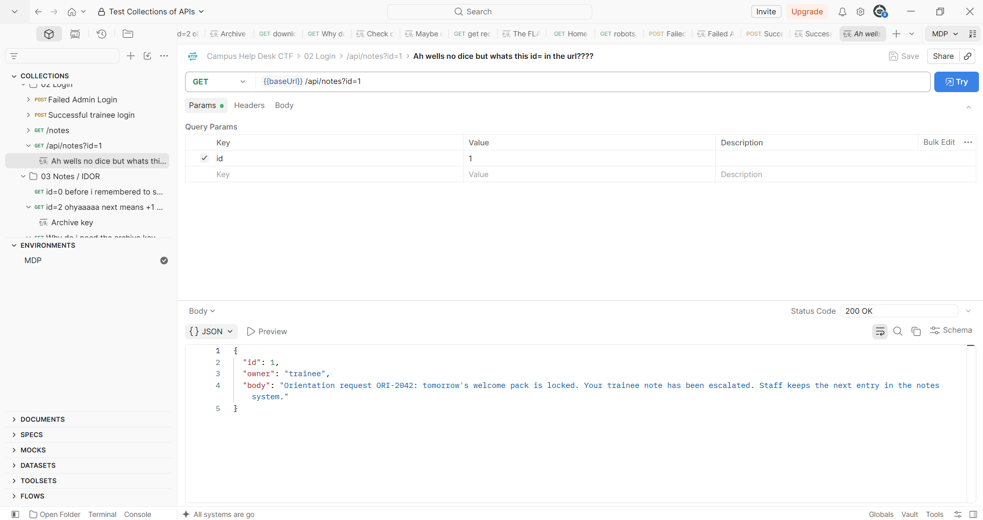
A suggestive URL for IDOR
Hypothesis. The record is chosen by a plain number in the URL, and the note says staff keeps "the next entry". If the server checks only that I'm logged in and not whether I own the note, changing id will return someone else's note.
Test. While signed in as trainee, I changed only the id value. id=0 returned 404 "Note not found". id=2 (the "next entry") returned:
{
"id": 2,
"owner": "staff",
"body": "Staff escalation for ORI-2042. The orientation archive needs the access key below. The recovery document is private; ordinary downloads start in the public directory.",
"archive_key": "92a56d0d30510472028863ad1c510a5b",
"recovery_file": "orientation-recovery-39a5975b500b5e4c.txt"
}
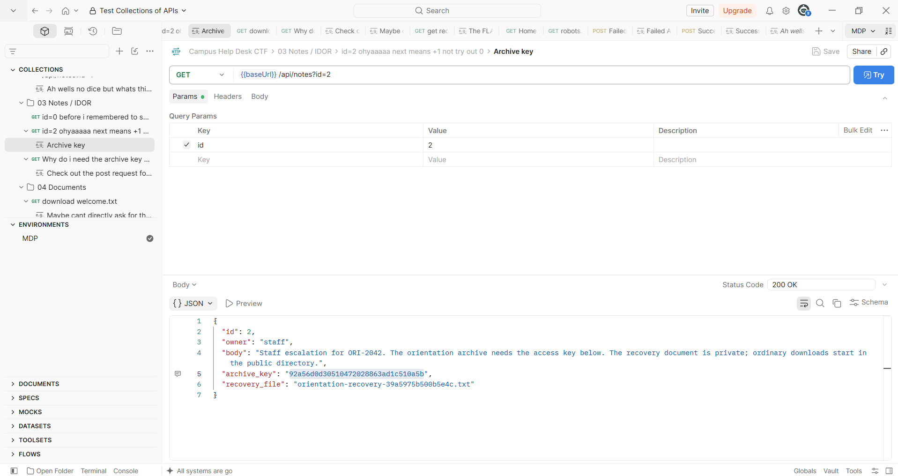
id=2 has an archive key
Result. 200 OK with "owner": "staff" while signed in as trainee. This confirms the server doesn't check ownership. (An early attempt returned 401 because the session cookie wasn't being sent. A 401 means "not logged in" and isn't an ownership check.)
Impact. Any signed-in user can read every note by counting through IDs. Here that leaked the staff archive key and the private recovery filename.
Mitigation. On every request, check server-side that the note's owner matches the session user, and return 403 or 404 otherwise. Unguessable IDs make enumeration harder but don't replace the ownership check.

Finding 3: Path traversal on /download
Observation. /documents has a GET form that sends key and file to /download (default file=welcome.txt). With the archive key, the baseline request returned:
Orientation archive: public downloads are read from the public/ directory.
Recovery documents are stored in its sibling private/ directory.
The staff escalation note records the current recovery document name.
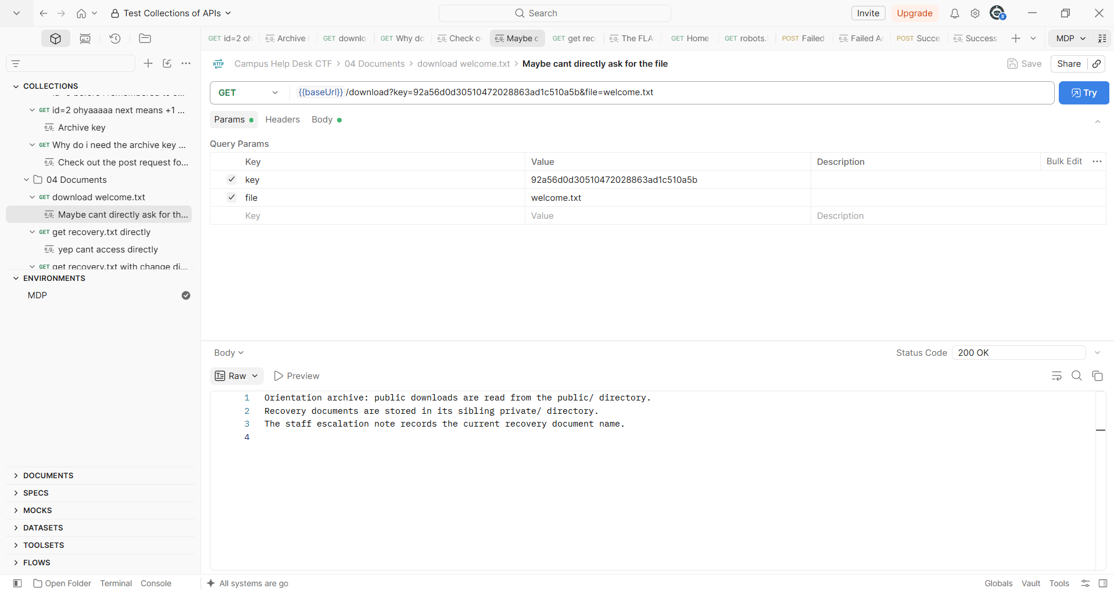
Download with welcome.txt
Then I changed one thing at a time to see what the endpoint checks:
Request (one change from the baseline) | Response | What it shows
key=wrong, file=welcome.txt | 403 "Archive access requires the key recorded in the staff escalation note." | The archive key is checked
Valid key and file, no session cookie | 401 (login page) | A login is required
file=orientation-recovery-39a5975b500b5e4c.txt | 404 "Document not found." | The filename is looked up inside public/ only

So the endpoint checks who is asking and whether they have the key, but the 404 suggests it doesn't control where the file path leads beyond prefixing public/.
Hypothesis. The server builds the path as public/ + file without checking the result. Since private/ is a sibling of public/, ../private/<name> should resolve to the private file.
Test. Same key, with only file changed:
GET /download?key=92a56d0d30510472028863ad1c510a5b&file=../private/orientation-recovery-39a5975b500b5e4c.txt
Result. 200 OK with the recovery document and the flag.
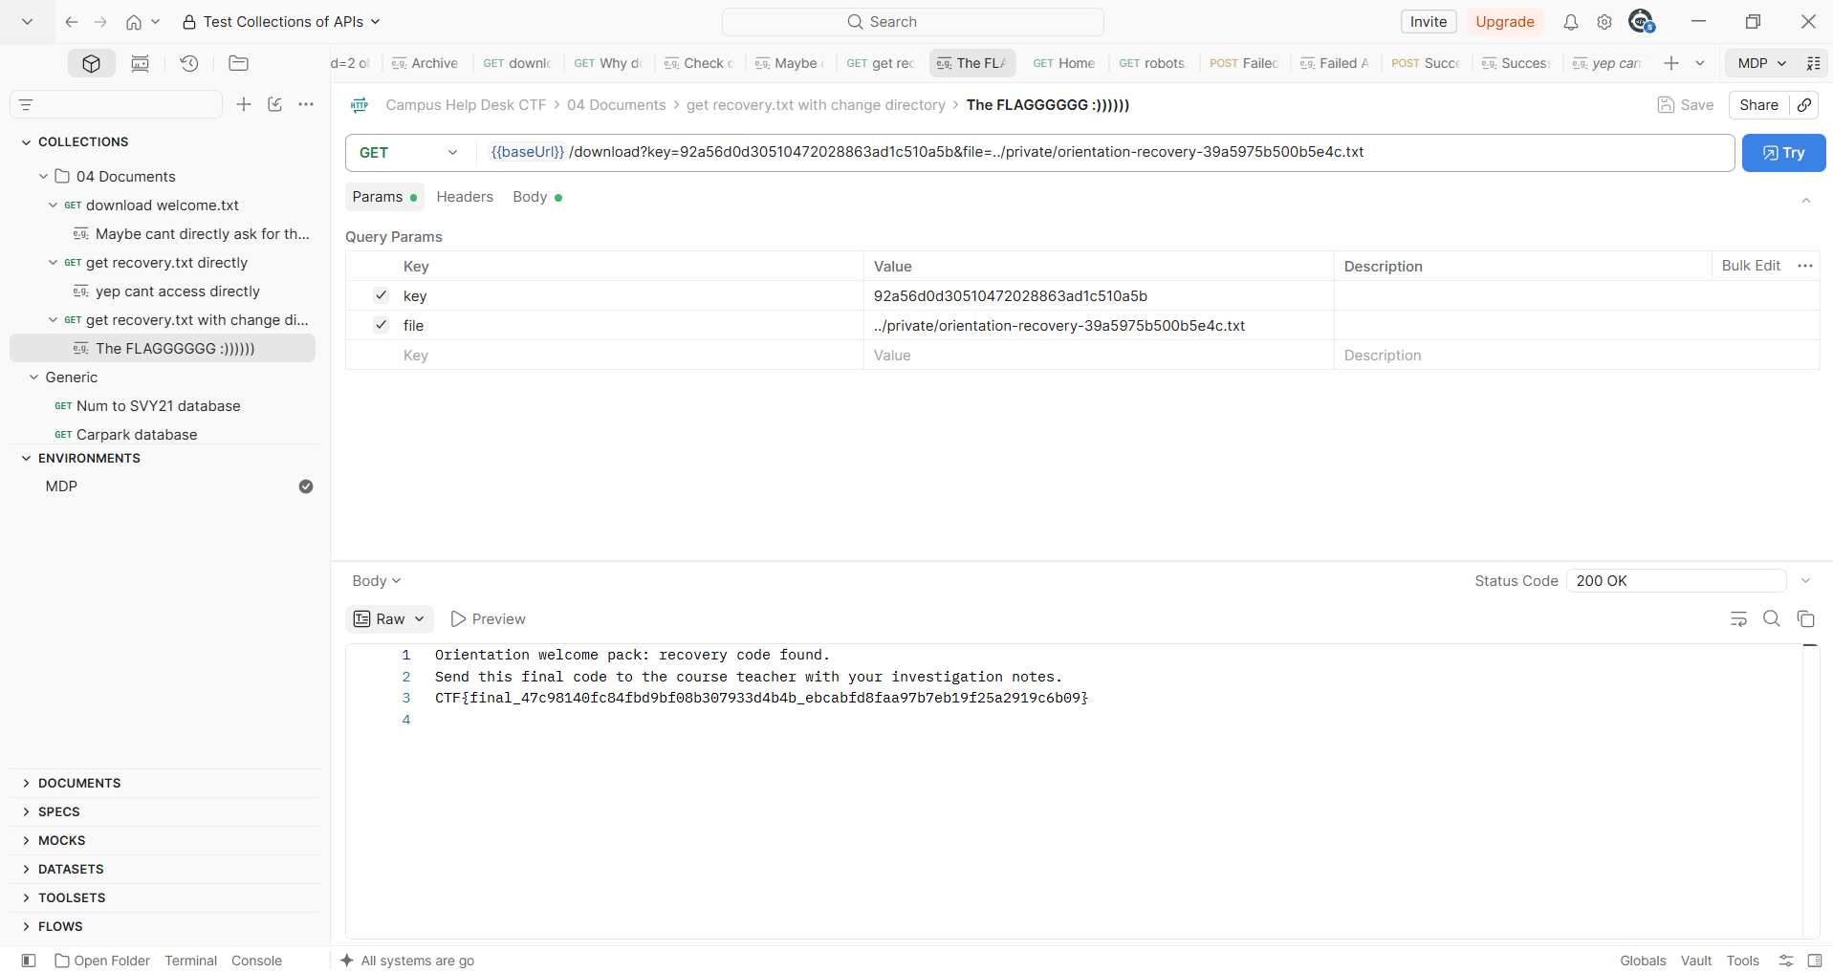
Download with a changed directory
Impact. The login and key checks pass, and the path is still never checked. Any signed-in user with the archive key (which Finding 2 leaks to every user) can read files outside the public directory, which defeats the public/private separation.
Mitigation. Resolve the full path and reject the request if it's not inside public/. Better still, don't accept filenames: map document IDs to files on the server. Run the service with the smallest file-system access it needs.

Flag
CTF{final_47c98140fc84fbd9bf08b307933d4b4b_ebcabfd8faa97b7eb19f25a2919c6b09}
Format check: it starts with CTF{final_, has two 32-character lowercase hex parts and ends with }.

How the LLM was used
The chatbot worked as a reasoning partner, not as the testing tool. I used it to:
- Interpret clues (robots.txt isn't access control; "next entry" points to the next ID; "sibling directory" means ../).
- Understand why a request returned 401 (missing session cookie) and how that differs from an ownership check (403/404).
- Learn how to recreate the browser's form login in Postman (x-www-form-urlencoded, cookie jar) and how to organise requests and evidence into a collection.
I sent every request myself and checked each suggestion against what the lab actually returned.

Reproducing
- docker compose up -d, then import Campus Help Desk CTF.postman_collection.json into Postman.
- Set the collection variable baseUrl to http://127.0.0.1:8080. The export saves it empty.
- Run the folders in order: 01 Recon → 02 Login → 03 Notes / IDOR → 04 Documents.
- docker compose down when finished.
To reproduce without Postman, follow CURL_STEPS.md.

